Core Java

What is Java?

Java is a **programming language** and a **platform**. Java is a high level, robust, object-oriented and secure programming language.

Java was developed by *Sun Microsystems* (which is now the subsidiary of Oracle) in the year 1995. *James Gosling* is known as the father of Java. Before Java, its name was *Oak*. Since Oak was already a registered company, so James Gosling and his team changed the name from Oak to Java.

**Platform**: Any hardware or software environment in which a program runs, is known as a platform. Since Java has a runtime environment (JRE) and API, it is called a platform.

Java Example

**Simple.java**

1. **class** Simple{
2. **public** **static** **void** main(String args[]){
3. System.out.println("Hello Java");
4. }
5. }

Application

According to Sun, 3 billion devices run Java. There are many devices where Java is currently used. Some of them are as follows:

1. Desktop Applications such as acrobat reader, media player, antivirus, etc.
2. Web Applications such as irctc.co.in, javatpoint.com, etc.
3. Enterprise Applications such as banking applications.
4. Mobile
5. Embedded System
6. Smart Card
7. Robotics
8. Games, etc.

Types of Java Applications

There are mainly 4 types of applications that can be created using Java programming:

1) Standalone Application

Standalone applications are also known as desktop applications or window-based applications. These are traditional software that we need to install on every machine. Examples of standalone application are Media player, antivirus, etc. AWT and Swing are used in Java for creating standalone applications.

2) Web Application

An application that runs on the server side and creates a dynamic page is called a web application. Currently, [Servlet](https://www.javatpoint.com/servlet-tutorial), [JSP](https://www.javatpoint.com/jsp-tutorial), [Struts](https://www.javatpoint.com/struts-2-tutorial), [Spring](https://www.javatpoint.com/spring-tutorial), [Hibernate](https://www.javatpoint.com/hibernate-tutorial), [JSF](https://www.javatpoint.com/jsf-tutorial), etc. technologies are used for creating web applications in Java.

3) Enterprise Application

An application that is distributed in nature, such as banking applications, etc. is called an enterprise application. It has advantages like high-level security, load balancing, and clustering. In Java, [EJB](https://www.javatpoint.com/ejb-tutorial) is used for creating enterprise applications.

4) Mobile Application

An application which is created for mobile devices is called a mobile application. Currently, Android and Java ME are used for creating mobile applications.

Java Platforms / Editions

There are 4 platforms or editions of Java:

1) Java SE (Java Standard Edition)

It is a Java programming platform. It includes Java programming APIs such as java.lang, java.io, java.net, java.util, java.sql, java.math etc. It includes core topics like OOPs, [String](https://www.javatpoint.com/java-string), Regex, Exception, Inner classes, Multithreading, I/O Stream, Networking, AWT, Swing, Reflection, Collection, etc.

2) Java EE (Java Enterprise Edition)

It is an enterprise platform that is mainly used to develop web and enterprise applications. It is built on top of the Java SE platform. It includes topics like Servlet, JSP, Web Services, EJB, [JPA](https://www.javatpoint.com/jpa-tutorial), etc.

3) Java ME (Java Micro Edition)

It is a micro platform that is dedicated to mobile applications.

4) JavaFX

It is used to develop rich internet applications. It uses a lightweight user interface API.

Prerequisite

To learn Java, you must have the basic knowledge of C/C++ programming language.

Audience

Our Java programming tutorial is designed to help beginners and professionals.

Problem

We assure that you will not find any problem in this Java tutorial. However, if there is any mistake, please post the problem in the contact form.

# **Difference between JDK, JRE, and JVM**

### **JVM**

JVM (Java Virtual Machine) is an abstract machine. It is called a virtual machine because it doesn't physically exist. It is a specification that provides a runtime environment in which Java bytecode can be executed. It can also run those programs which are written in other languages and compiled to Java bytecode.

JVMs are available for many hardware and software platforms. JVM, JRE, and JDK are platform dependent because the configuration of each [OS](https://www.javatpoint.com/os-tutorial) is different from each other. However, Java is platform independent. There are three notions of the JVM: specification, implementation, and instance.

The JVM performs the following main tasks:

* Loads code
* Verifies code
* Executes code
* Provides runtime environment

[More Details.](https://www.javatpoint.com/internal-details-of-jvm)

### **JRE**

JRE is an acronym for Java Runtime Environment. It is also written as Java RTE. The Java Runtime Environment is a set of software tools which are used for developing Java applications. It is used to provide the runtime environment. It is the implementation of JVM. It physically exists. It contains a set of libraries + other files that JVM uses at runtime.

The implementation of JVM is also actively released by other companies besides Sun Micro Systems.

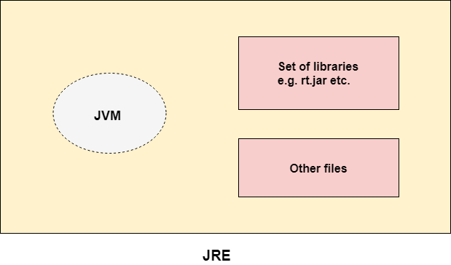

### **JDK**

JDK is an acronym for Java Development Kit. The Java Development Kit (JDK) is a software development environment which is used to develop Java applications and [applets](https://www.javatpoint.com/java-applet). It physically exists. It contains JRE + development tools.

JDK is an implementation of any one of the below given Java Platforms released by Oracle Corporation:

* Standard Edition Java Platform
* Enterprise Edition Java Platform
* Micro Edition Java Platform

The JDK contains a private Java Virtual Machine (JVM) and a few other resources such as an interpreter/loader (java), a compiler (javac), an archiver (jar), a documentation generator (Javadoc), etc. to complete the development of a Java Application.

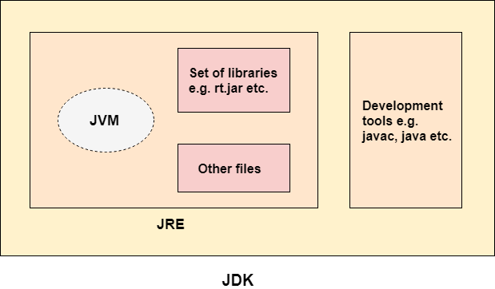

# **Java OOPs Concepts**

**Simula** is considered the first object-oriented programming language. The programming paradigm where everything is represented as an object is known as a truly object-oriented programming language.

**Smalltalk** is considered the first truly object-oriented programming language.

The popular object-oriented languages are [Java](https://www.javatpoint.com/java-tutorial), [C#](https://www.javatpoint.com/c-sharp-tutorial), [PHP](https://www.javatpoint.com/php-tutorial), [Python](https://www.javatpoint.com/python-tutorial), [C++](https://www.javatpoint.com/cpp-tutorial), etc.

The main aim of object-oriented programming is to implement real-world entities, for example, object, classes, abstraction, inheritance, polymorphism, etc.

## OOPs (Object-Oriented Programming System)

**Object** means a real-world entity such as a pen, chair, table, computer, watch, etc. **Object-Oriented Programming** is a methodology or paradigm to design a program using classes and objects. It simplifies software development and maintenance by providing some concepts:

* [Object](https://www.javatpoint.com/object-and-class-in-java)
* Class
* [Inheritance](https://www.javatpoint.com/inheritance-in-java)
* [Polymorphism](https://www.javatpoint.com/runtime-polymorphism-in-java)
* [Abstraction](https://www.javatpoint.com/abstract-class-in-java)
* [Encapsulation](https://www.javatpoint.com/encapsulation)

Apart from these concepts, there are some other terms which are used in Object-Oriented design:

* Coupling
* Cohesion
* Association
* Aggregation
* Composition

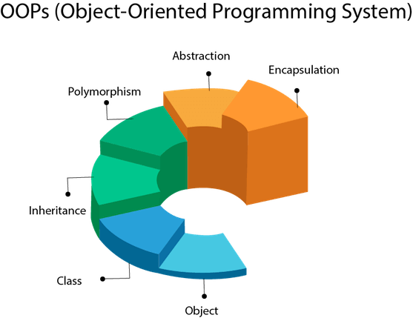

## Object

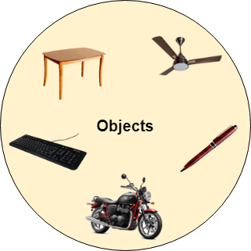

Any entity that has state and behavior is known as an object. For example, a chair, pen, table, keyboard, bike, etc. It can be physical or logical.

An Object can be defined as an instance of a class. An object contains an address and takes up some space in memory. Objects can communicate without knowing the details of each other's data or code. The only necessary thing is the type of message accepted and the type of response returned by the objects.

**Example:** A dog is an object because it has states like color, name, breed, etc. as well as behaviors like wagging the tail, barking, eating, etc.

## Class

Collection of objects is called class. It is a logical entity.

A class can also be defined as a blueprint from which you can create an individual object. Class doesn't consume any space.

### **Inheritance**

When one object acquires all the properties and behaviors of a parent object, it is known as inheritance. It provides code reusability. It is used to achieve runtime polymorphism.

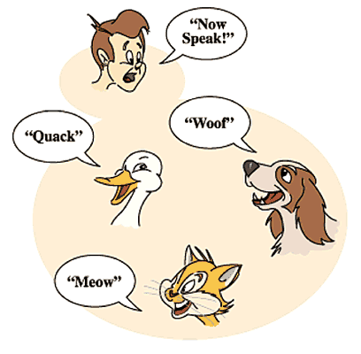

### **Polymorphism**

If one task is performed in different ways, it is known as polymorphism. For example: to convince the customer differently, to draw something, for example, shape, triangle, rectangle, etc.

In Java, we use method overloading and method overriding to achieve polymorphism.

Another example can be to speak something; for example, a cat speaks meow, dog barks woof, etc.

#### Abstraction

Hiding internal details and showing functionality is known as abstraction. For example phone call, we don't know the internal processing.

In Java, we use abstract class and interface to achieve abstraction.



### **Encapsulation**

Binding (or wrapping) code and data together into a single unit are known as encapsulation. For example, a capsule, it is wrapped with different medicines.

A java class is the example of encapsulation. Java bean is the fully encapsulated class because all the data members are private here.

### **Coupling**

Coupling refers to the knowledge or information or dependency of another class. It arises when classes are aware of each other. If a class has the details information of another class, there is strong coupling. In Java, we use private, protected, and public modifiers to display the visibility level of a class, method, and field. You can use interfaces for the weaker coupling because there is no concrete implementation.

### **Cohesion**

Cohesion refers to the level of a component which performs a single well-defined task. A single well-defined task is done by a highly cohesive method. The weakly cohesive method will split the task into separate parts. The java.io package is a highly cohesive package because it has I/O related classes and interface. However, the java.util package is a weakly cohesive package because it has unrelated classes and interfaces.

### **Association**

Association represents the relationship between the objects. Here, one object can be associated with one object or many objects. There can be four types of association between the objects:

* One to One
* One to Many
* Many to One, and
* Many to Many

Let's understand the relationship with real-time examples. For example, One country can have one prime minister (one to one), and a prime minister can have many ministers (one to many). Also, many MP's can have one prime minister (many to one), and many ministers can have many departments (many to many).

Association can be undirectional or bidirectional.

### **Aggregation**

Aggregation is a way to achieve Association. Aggregation represents the relationship where one object contains other objects as a part of its state. It represents the weak relationship between objects. It is also termed as a has-a relationship in Java. Like, inheritance represents the is-a relationship. It is another way to reuse objects.

### **Composition**

The composition is also a way to achieve Association. The composition represents the relationship where one object contains other objects as a part of its state. There is a strong relationship between the containing object and the dependent object. It is the state where containing objects do not have an independent existence. If you delete the parent object, all the child objects will be deleted automatically.

## Advantage of OOPs over Procedure-oriented programming language

1) OOPs makes development and maintenance easier, whereas, in a procedure-oriented programming language, it is not easy to manage if code grows as project size increases.

2) OOPs provides data hiding, whereas, in a procedure-oriented programming language, global data can be accessed from anywhere.

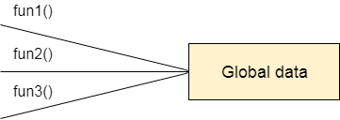

Figure: Data Representation in Procedure-Oriented Programming

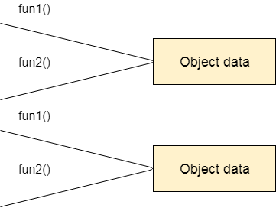

Figure: Data Representation in Object-Oriented Programming

3) OOPs provides the ability to simulate real-world event much more effectively. We can provide the solution of real word problem if we are using the Object-Oriented Programming language.

## What is the difference between an object-oriented programming language and object-based programming language?

Object-based programming language follows all the features of OOPs except Inheritance. JavaScript and VBScript are examples of object-based programming languages.